Weather Forecasting App

Team: 4 not 5

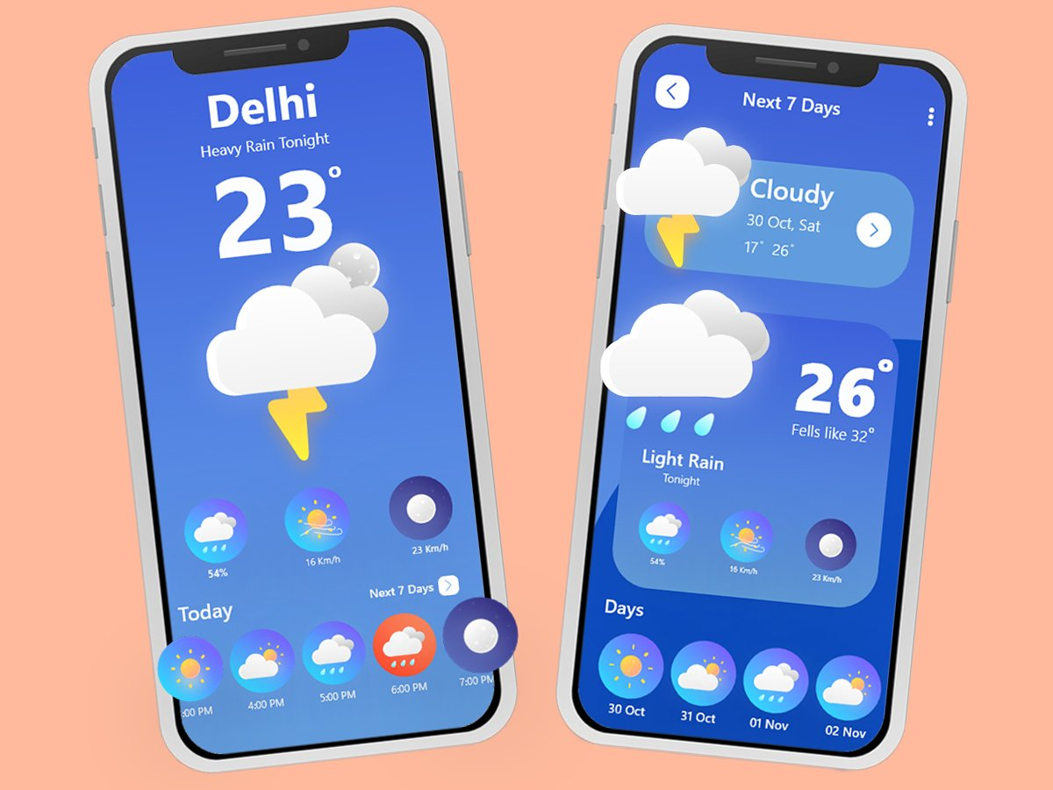

Pavan Sanwlot

TAble of  
Contents

Introduction 1

Abstract 1

Objectives 2

System Components 2

Features 3

Technogoly Stack ....................................................................3

Project Setup .........................................................................4

Conclusion .............................................................................6

# IntroDuction Java Project

The Weather Forecasting App is a Java-based application designed to provide users with accurate and real-time weather information and forecasts. The app leverages data from a reliable weather API to offer current weather conditions, future forecasts, and weather alerts. It aims to assist users in planning their activities based on reliable weather data.

## Abstract

The Weather Forecasting App is an individual project by Pavan Sanwlot, proposed for the team "4 not 5." This document outlines the process and requirements from project setup to finalization, ensuring a concise and structured approach to developing a robust weather forecasting application.

“Team 4~~0~~5”

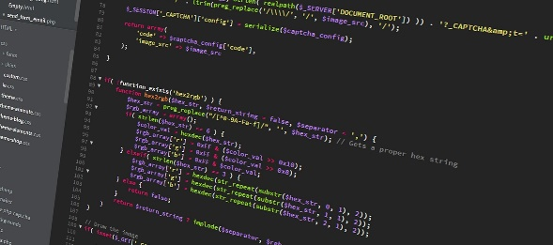

## Objectives

* Provide Accurate Weather Data: Deliver current weather conditions and forecasts using a reliable API.
* User-Friendly Interface: Create an intuitive and easy-to-use interface for users to interact with.
* Real-Time Updates: Ensure the app provides real-time weather updates.
* Error Handling: Implement robust error handling to manage network issues and invalid user inputs.

**SYSTEM COMPONENTS**

1. Frontend (User Interface):

* Built using JavaFX or Swing.
* Input field for entering city names.
* Display areas for showing current weather, forecast, and weather alerts.

1. Backend (Data Handling):

* Connects to the weather API.
* Fetches and parses weather data.
* Handles network requests and responses.

## features

1. **Current Weather Information**: Displays the current weather conditions for a specified location.
2. **5-Day Forecast**: Provides a forecast for the next five days.
3. **Weather Alerts**: Displays alerts for severe weather conditions.
4. **Error Messages**: Informs users about invalid inputs or network issues.
5. **Weather Icons**: Shows weather icons corresponding to different weather conditions.
6. **Temperature Units**: Allows users to toggle between Celsius and Fahrenheit.

**Technology Stack**

1. **Programming Language**: Java
2. **Integrated Development Environment (IDE)**: IntelliJ IDEA,VS Code, Eclipse, or NetBeans
3. **Weather API**: OpenWeatherMap or similar
4. **Libraries**:
   * JSON parsing library (e.g., org.json or Gson)
   * JavaFX or Swing for GUI
5. **Build Tool**: Maven or Gradle (optional, for dependency management)

## Project setup

**Step 1: Setting Up the Development Environment**

1. **Install JDK**:
   * Download and install JDK from the [Oracle website](https://www.oracle.com/java/technologies/javase-downloads.html).
   * Set up the JAVA_HOME environment variable.
2. **Choose an IDE**:
   * Download and install IntelliJ IDEA, Eclipse, or NetBeans.
   * Configure the IDE with the installed JDK.
3. **Create a New Java Project**:
   * Open the IDE and create a new Java project.
   * Set up the project structure with separate folders for source code (**src**) and resources (**resources**).

**Step 2: Integrating the Weather API**

1. **Sign Up for a Weather API**:
   * Register and obtain an API key from a weather service provider (e.g., OpenWeatherMap).
2. **Add Dependencies**:
   * If using Maven or Gradle, add the necessary dependencies for JSON parsing (e.g., org.json or Gson).

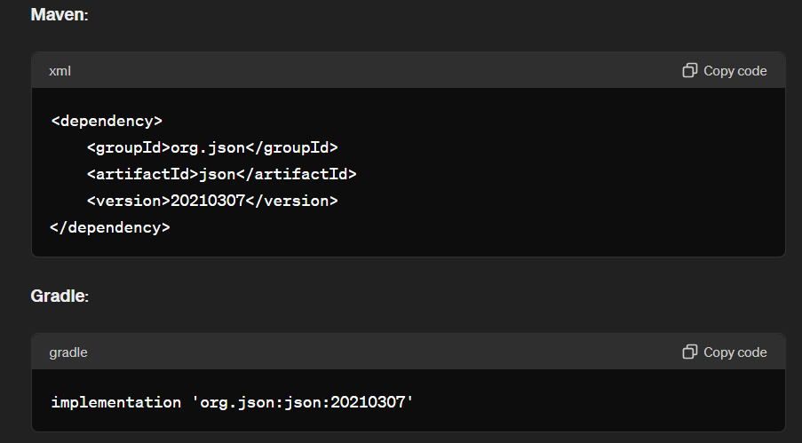

**Step 3: Developing the Application**

1. **Create a User Interface**:
   * Design a simple GUI using JavaFX or Swing.
   * Add components like text fields, buttons, and labels for displaying weather information.
2. **Implement Backend Logic**:
   * Write methods to connect to the weather API, fetch data, and parse JSON responses.
   * Use HttpURLConnection or a third-party library like OkHttp for handling network requests.
3. **Handle User Input**:
   * Capture the city name entered by the user.
   * Trigger API requests based on user input and update the UI with the fetched weather data.
4. **Error Handling**:
   * Implement try-catch blocks to manage potential exceptions.
   * Display user-friendly error messages for invalid inputs or network issues.

**Step 4: Testing the Application**

1. **Unit Testing**:
   * Write unit tests for critical methods using JUnit.
   * Test JSON parsing, API connectivity, and UI updates.
2. **User Testing**:
   * Conduct user testing to gather feedback on the app's usability and functionality.
   * Make necessary adjustments based on user feedback.

**Step 5: Finalizing the Project**

1. **Code Review and Optimization**:
   * Review the code for any inefficiencies or bugs.
   * Optimize the code for better performance and readability.
2. **Documentation**:
   * Document the code with comments and Javadoc.
   * Prepare a user guide explaining how to use the app.
3. **Deployment**:
   * Package the application into an executable JAR file.
   * Provide instructions for running the application.

## CONCLUSION

The Weather Forecasting App project aims to deliver a reliable and user-friendly tool for accessing real-time weather information. By following the outlined process and meeting the specified requirements, the project will achieve its goal of providing accurate weather forecasts to users. This documentation serves as a guide to ensure the project's successful completion and deployment.